**CAPSTONE**

**Battle of the Neighborhoods**

**Indian Restaurants**

*Ashutosh Upadhayay*

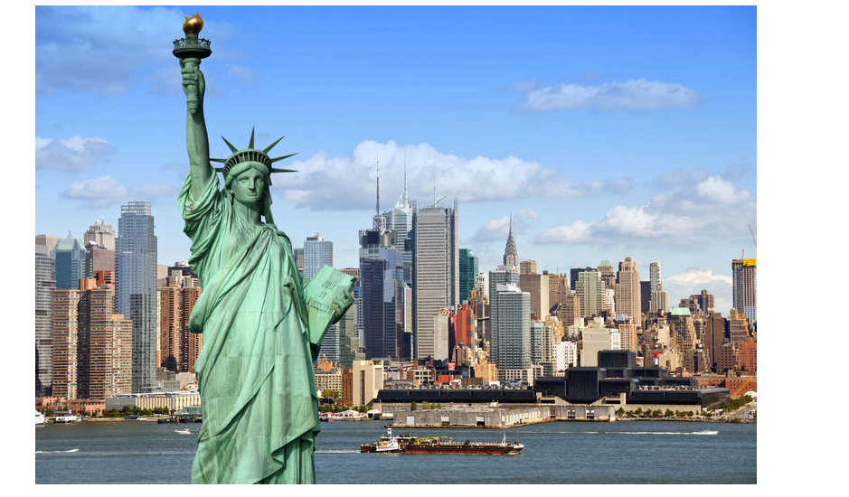

**Introduction: Business Problem**

New York City (NYC), also known as the City of New York or simply New York (NY), is the most populous city in the United States. With an estimated 2018 population of 8,398,748 distributed over a land area of about 302.6 square miles (784 km2), New York is also the most densely populated major city in the United States.Located at the southern tip of the state of New York, the city is the center of the New York metropolitan area, the largest metropolitan area in the world by urban landmass and one of the world's most populous mega cities, with an estimated 19,979,477 people in its 2018 Metropolitan Statistical Area and 22,679,948 residents in its Combined Statistical Area.

A global power city, New York City has been described as the cultural, financial,and media capital of the world, and exerts a significant impact upon commerce, entertainment, research, technology, education, politics, tourism, art, fashion, and sports. The city's fast pace has inspired the term New York minute.Home to the headquarters of the United Nations,New York is an important center for international diplomacy & community.

##### **Indians in the New York City metropolitan region**

Indians in the New York City metropolitan region constitute one of the largest and fastest growing ethnicities in the New York City metropolitan area of the United States. The New York City region is home to the largest Indian American population among metropolitan areas by a significant margin, enumerating 711,174 uniracial individuals by the 2013- 2017 U.S. Census American Community Survey estimates

With almost 700K inhabitants reporting Indian ancestry , the need to find and enjoy Indian cuisines is on the rise and demand.We are going to explore which neighborhoods and boroughs of New York City have the most as well as the best Indian restaurants. Additionally, I will attempt to answer the questions “Where should I open an Indian Restaurant?” and “Where should I stay If I want great Indian food?”

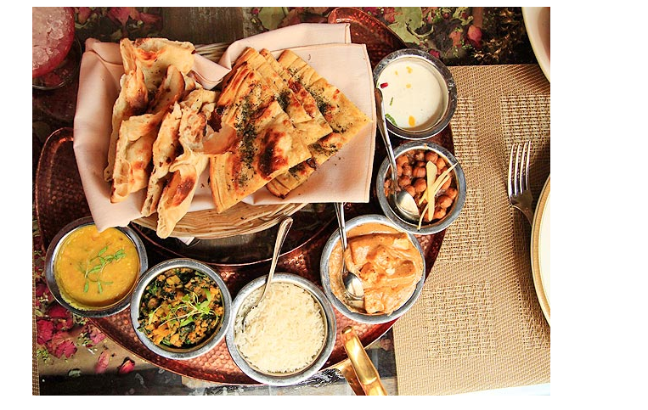

**Problem Statement**

1. What is / are the best location(s) for Indian cuisine in New York City?
2. In what Neighborhood and/or borough should I open an Indian restaurant to have the best chance of being successful?
3. Where would I go in New York City to have the best Indian food?

**Data**

In order to answer the above questions, data on New York City neighborhoods, boroughs to include boundaries, latitude, longitude, restaurants, and restaurant ratings and tips are required.

New York City data containing the neighborhoods and boroughs, latitudes, and longitudes will be obtained from the data source: <https://cocl.us/new_york_dataset>

New York City data containing neighborhood boundaries will be obtained from the data source: <https://data.cityofnewyork.us/City-Government/Borough-Boundaries/tqmj-j8zm>

All data related to locations and quality of Indian restaurants will be obtained via the FourSquare API utilized via the Request library in Python.

**Methodology**

• Data will be collected from <https://cocl.us/new_york_dataset> and cleaned and processed into a dataframe.

• FourSquare be used to locate all venues and then filtered by Indian restaurants. Ratings, tips, and likes by users will be counted and added to the dataframe.

• Data will be sorted based on rankings

• Finally, the data be will be visually assessed using graphing from various Python libraries.

**Analysis**

Click [here](https://github.com/ashutosh061982/Coursera_Capstone/blob/master/BattleOfNeighbourhoods_Code.ipynb)for full code.

## Results and Discussion

Analysis shows and reveals New York City encompasses five county-level administrative divisions called boroughs: The Bronx, Brooklyn, Manhattan, Queens, and Staten Island. Out of which Queens , Staten Islands and Brooklyn having the high number of neighborhoods respectively , after that Bronx & Manhattan with less number.

## 

Graph plot shows that Queens have the highest number of neighborhoods and Indian restaurants , Bronx and Staten Island have the least number of Indian restaurants.Additionally we can see that Brooklyn & Manhattan are also having the good numbers in terms of Indian restaurants.

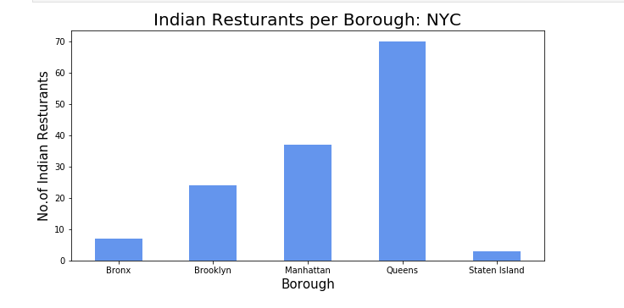

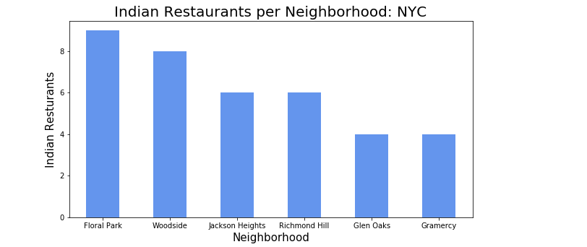

Interesting fact is although Queens which is having the highest number of neighborhoods and Indian restaurants , but Brooklyn & Manhattan wins the place for best locations based on Average Rating of restaurants . Even all top six neighborhoods with highest number of Indian restaurant are also present in Queens itself, but not having enough average rating to qualify for the best place for Indian Food .

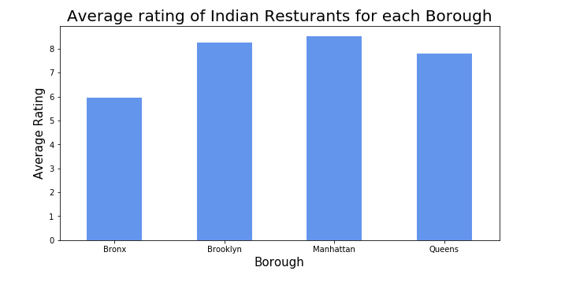

Queens is the most dense borough in regards to Indian Restaurants making competition high.Boroughs like Brooklyn & Manhattan provides less competition based on Indian restaurant density but maintaining the high average ratings.

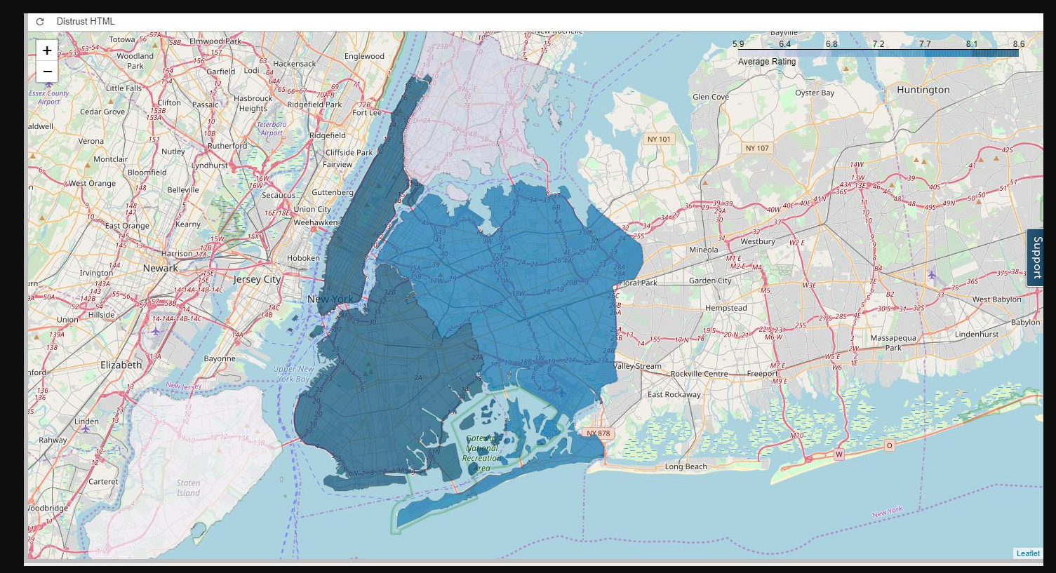

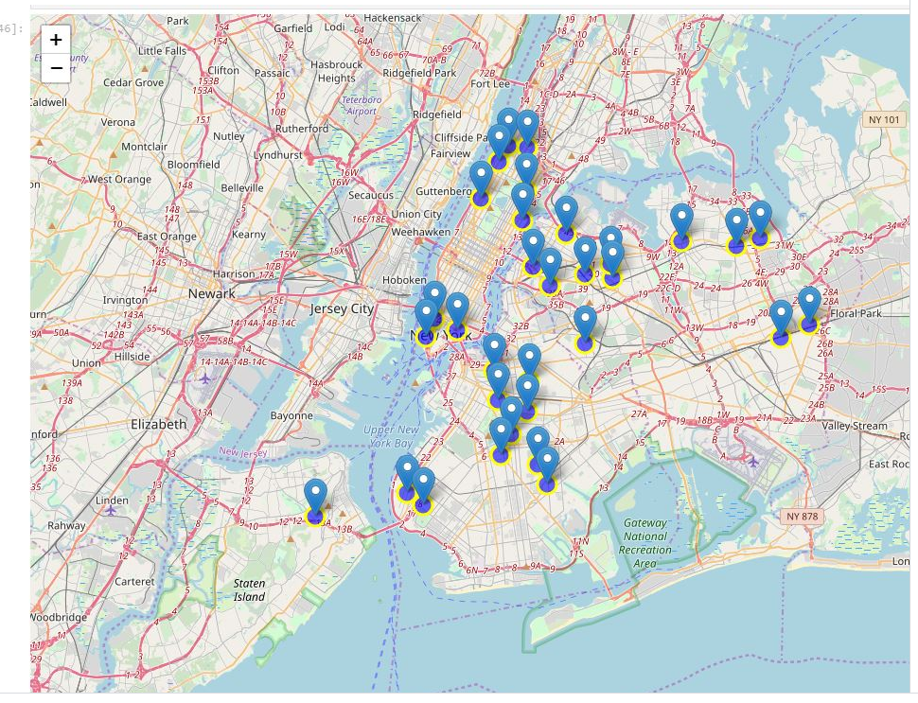

**So at last finally we can say that based on above data and analysis :**

1. **Best location(s) for Indian cuisine in New York City are Brooklyn & Manhattan based on average ratings.**
2. **Brooklyn & Manhattan provides less competition but maintains the high average ratings , Queens is highly competitive but don't have good ratings for the existing restaurants.**
3. **Best Indian food should be at Tamarind TriBeCa in Manhattan.**

## Conclusion

Purpose of this project was to identify the Best location(s) for Indian cuisine and place for Best Indian Food. Additionally it also helps in identifying NYC areas close to center with low number of restaurants (particularly Indian restaurants) in order to aid stakeholders in narrowing down the search for optimal location for a new Indian restaurant.

Final decision on optimal restaurant location will be made by stakeholders based on specific characteristics of neighborhoods and locations in every recommended zone, taking into consideration additional factors like attractiveness of each location (proximity to park or water), levels of noise / proximity to major roads, real estate availability, prices, social and economic dynamics of every neighborhood etc.